Task 1.1:
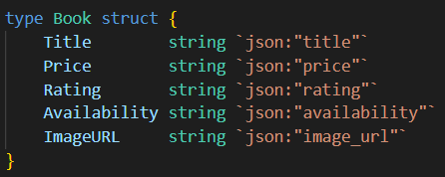
This part defines a Book struct, which holds the essential details of each book: title, price, rating, availability, and image URL.
It also makes use of JSON tags to simplify the process of serializing the data into JSON format.
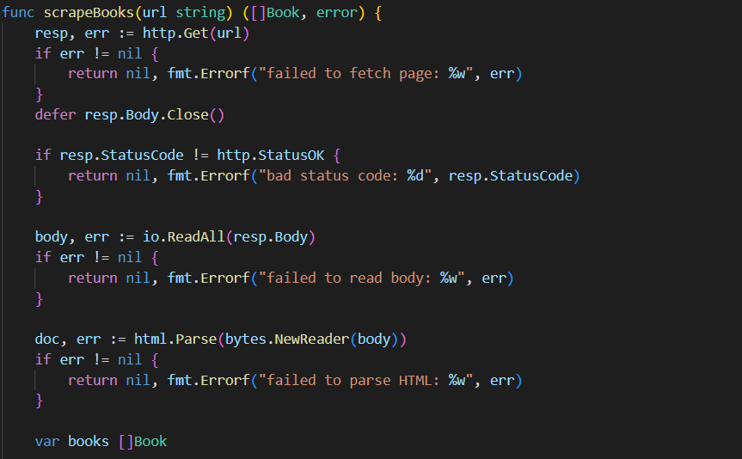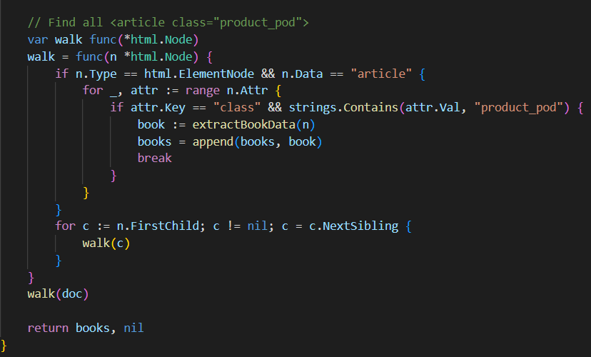
This function is responsible for gathering the book data. Here’s how it works:
- It sends an HTTP GET request to the target website URL.
- Once the page is fetched, it uses the golang.org/x/net/html package to parse the HTML content.
- The function then walks through the DOM tree, looking specifically for all <article class="product_pod"> elements. Each of these represents a single book on the page.
- Finally, it returns a slice of Book objects, each containing the extracted information for one book.

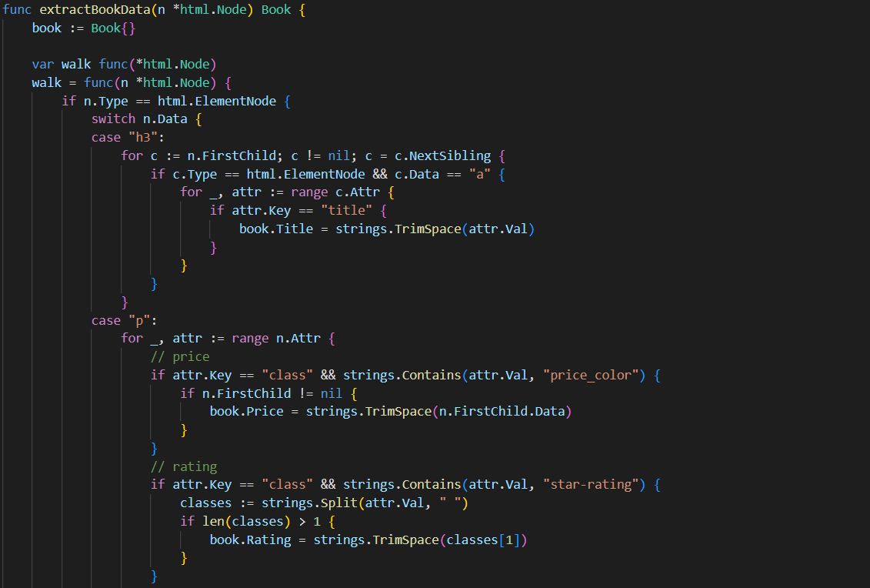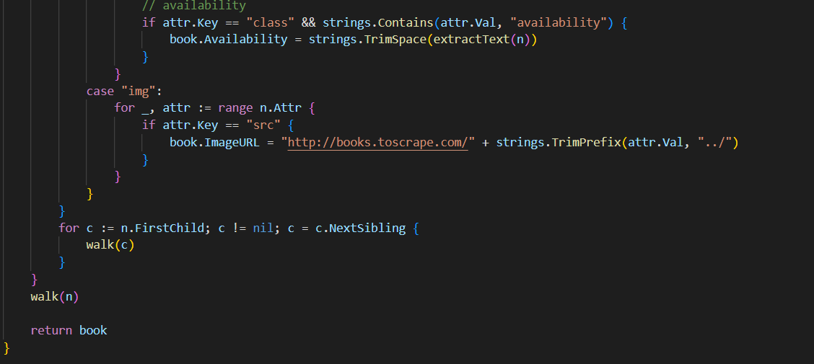
For each book article, this function pulls out the following details:
- Title: Extracted from the title attribute inside the <h3><a> tag.
- Price: Located within the <p class="price_color"> element.
- Rating: Found in the <p class="star-rating"> class (e.g., "Three", "Five", etc.).
- Availability: Taken from the <p class="availability"> element.
- Image URL: Constructed by extracting the src attribute from the <img> tag, and then prepending the base URL to form the complete link.

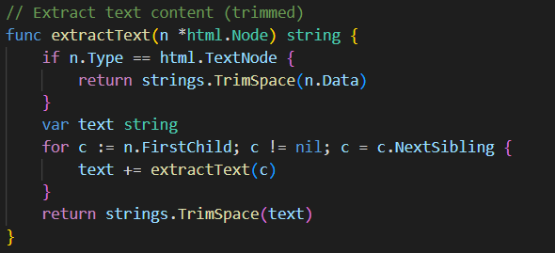
extractText(): This function recursively extracts text content from HTML nodes.

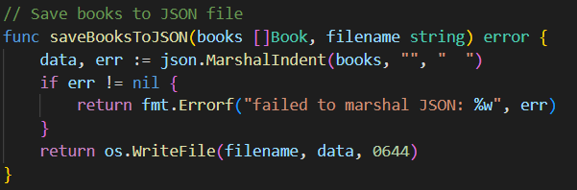
Converts price strings (e.g., "£51.77") to float64 for calculations

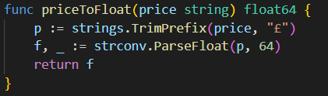
Marshals the book data to JSON format and saves to file

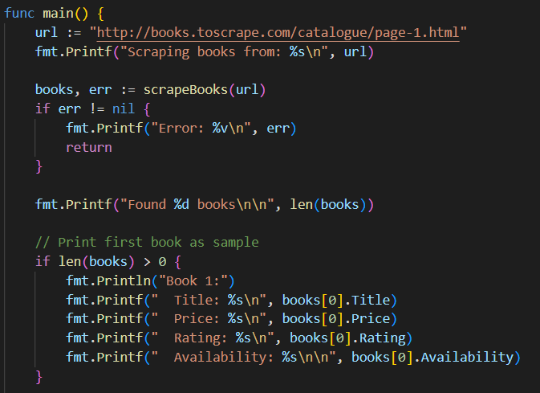
- Scrapes books from page 1
- Prints the first book as a sample
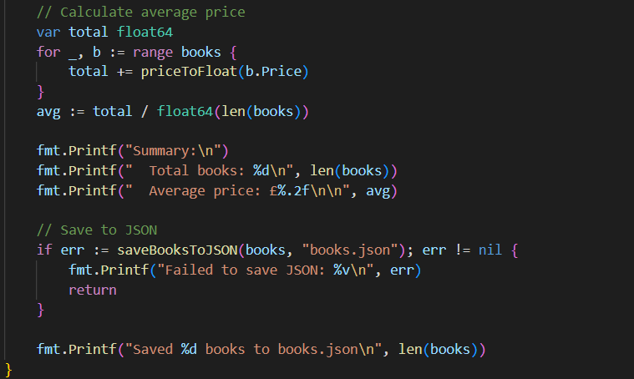
- Calculates and displays the average book price
- Saves all book data to books.json

Output:
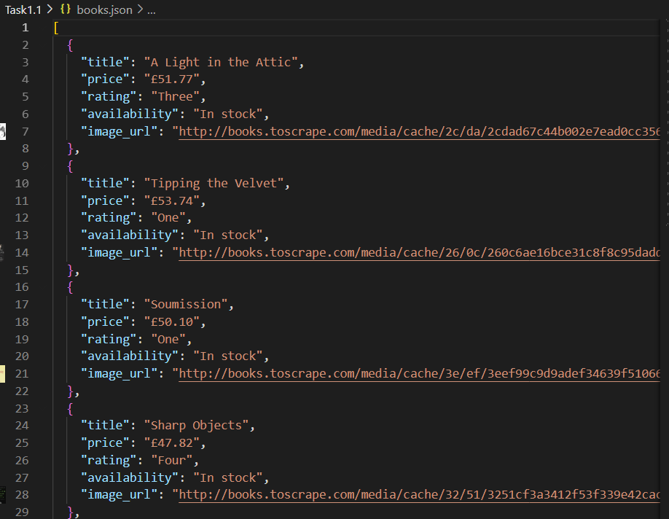

Task 2.1:
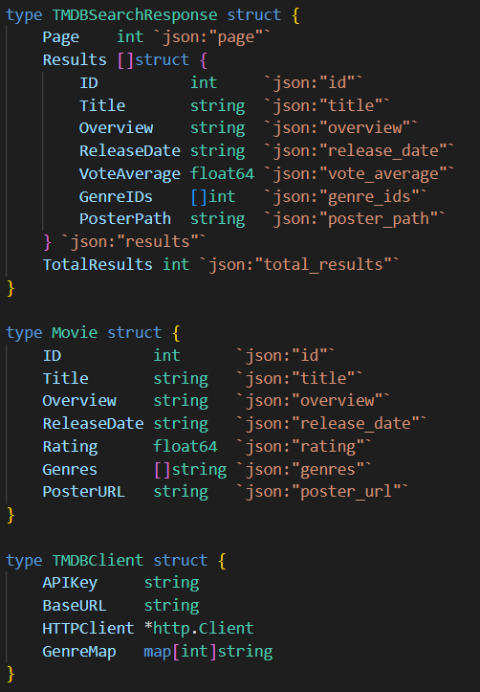
- TMDBSearchResponse: Represents the API response structure
- Movie: Custom structure to store processed movie information
- TMDBClient: Client wrapper with API key, HTTP client, and genre mapping

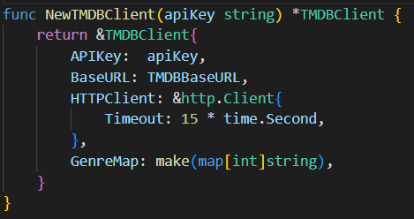
NewTMDBClient(): Constructor that initializes the client with a 15-second timeout

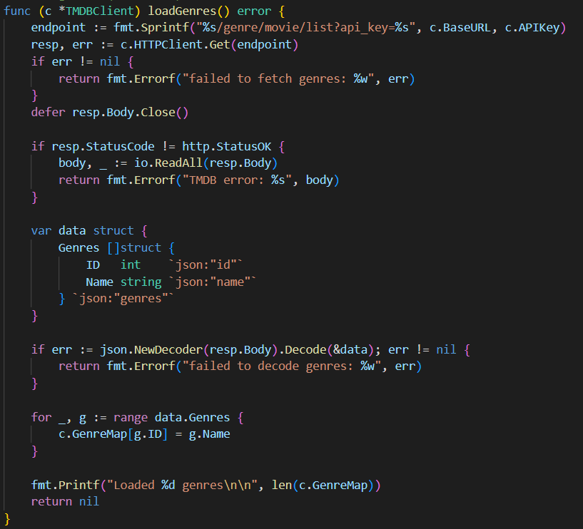
loadGenres(): Fetches the genre list from TMDB and creates a mapping from genre IDs to names

- 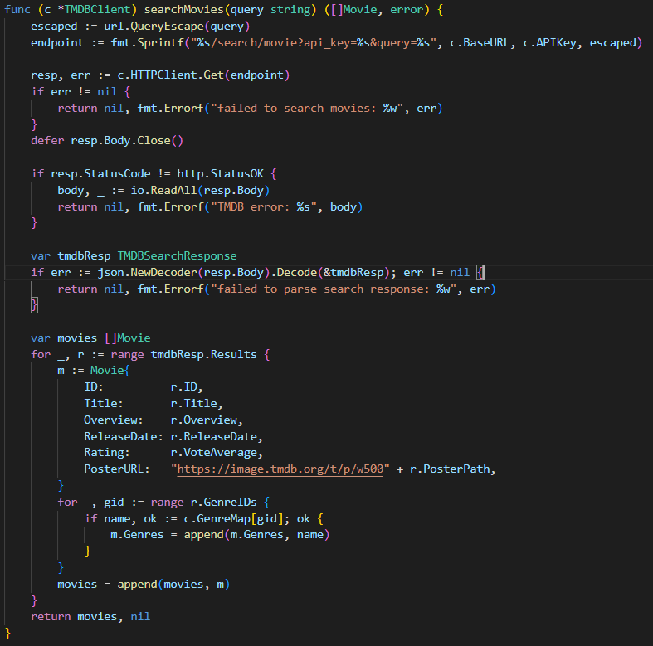 searchMovies():
  - URL-encodes the search query
  - Makes API request to the search endpoint
  - Converts TMDB response to custom Movie format
  - Maps genre IDs to genre names using the pre-loaded genre map
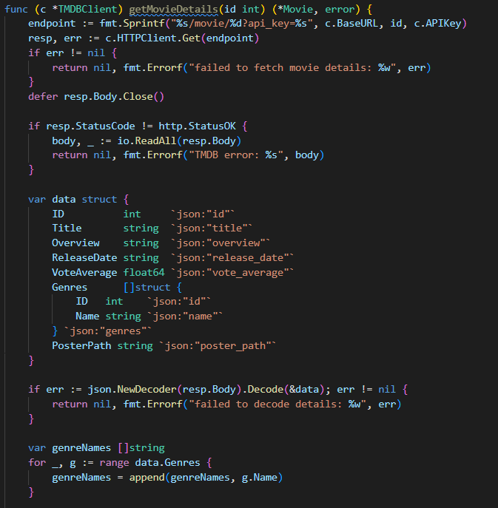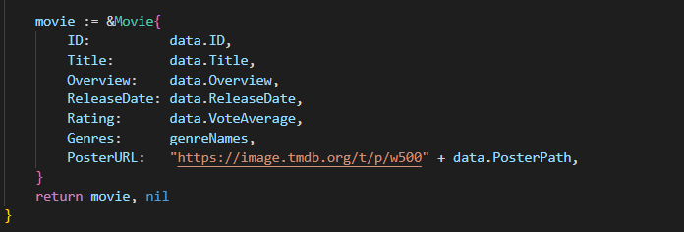
getMovieDetails(): Fetches detailed information for a specific movie by ID

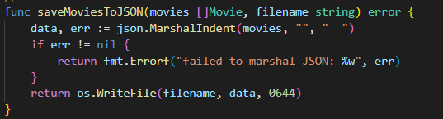
Marshals movie slice to formatted JSON

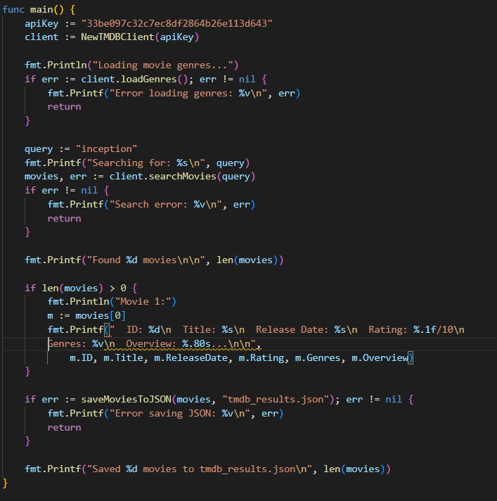
- Creates TMDB client with API key
- Loads genre mappings
- Searches for movies with query "inception"
- Displays the first movie's details
- Saves all results to tmdb_results.json
Output:
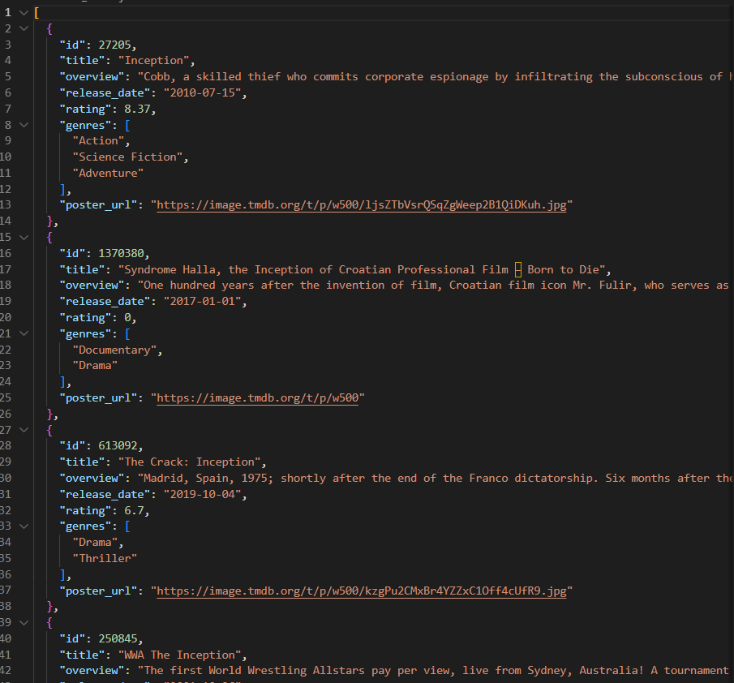

Task 2.2:
MovieInfo
- Unified movie data structure across all sources
- Fields: ID, Title, Director, Year, Description, Genres, Rating, Duration, Source, LastUpdated
- More comprehensive than the Movie struct from Task 2.1
MovieSource (interface)
- Defines contract for all movie data sources
- Methods: GetMovies(query, limit) and GetName()
TMDBSource
- Implements MovieSource for TMDB API
- Wraps the TMDBClient from previous code
- Converts Movie to MovieInfo format
MockScraperSource
- Implements MovieSource for simulated scraped data
- Returns fake movie data for testing
- Demonstrates how to add additional sources
MovieAggregator
- Combines multiple MovieSource implementations
- Orchestrates concurrent queries and result merging
Key Functions
NewTMDBSource(apiKey) *TMDBSource
- Creates TMDB source wrapper
- Initializes internal TMDB client
TMDBSource.GetMovies(query, limit) ([]MovieInfo, error)
- Loads genres if needed
- Searches TMDB using the client
- Converts results to MovieInfo format
- Extracts year from release date string
- Returns limited results
MockScraperSource.GetMovies(query, limit) ([]MovieInfo, error)
- Generates mock movie data based on query
- Returns predefined fake results for testing
- Useful for development without real scraper
NewMovieAggregator(sources...) *MovieAggregator
- Creates aggregator with variable number of sources
- Uses variadic parameter for flexibility
MovieAggregator.Search(query, limitPerSource) ([]MovieInfo, error)
- Main aggregation function
- Queries all sources concurrently using goroutines
- Each source runs in separate goroutine with go func()
- Uses sync.Mutex to protect shared allMovies slice
- Uses sync.WaitGroup to wait for all goroutines to complete
- Deduplicates results after collection
- Returns merged, deduplicated movie list
deduplicateMovies(movies) []MovieInfo
- Removes duplicate movies based on title similarity
- For each movie, finds all similar titles (≥80% similarity)
- Merges duplicate data:
  - Keeps highest rating
  - Combines all genres
  - Fills in missing director/duration
- Marks duplicates as "used" to skip them
- Sorts final results by rating (descending)
calculateSimilarity(title1, title2) float64
- Returns similarity score between two titles (0.0 to 1.0)
- Normalizes titles (lowercase, trim)
- Removes punctuation (:, -, ,)
- Calculates word overlap percentage
- Returns 0.9 if one title contains the other
- Uses word matching for similarity calculation
- Ignores short words (≤2 chars)
generateReport(movies)
- Prints comprehensive statistics:
  - Total movies found
  - Count by source
  - Top 10 genres by frequency
  - Average rating across all movies
- Sorts genres by count before displaying
saveToJSON(movies, filename) error
- Marshals movies to pretty-printed JSON
- Writes to file with 0644 permissions
- Returns formatted error if fails
main()
- Creates aggregator with TMDB + mock scraper
- Searches for "spider-man" with limit of 10 per source
- Displays top 5 deduplicated results with details
- Generates statistical report
- Saves all results to "aggregated_movies.json"

Output:
